MEMBERSHIP FORM
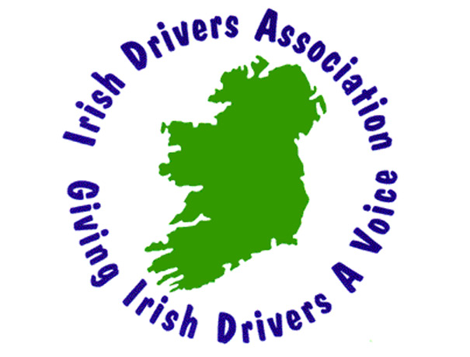

(* Please use BLOCK letters)

Name:

Address:

Tel No: |  | Signature:
Sponsor:  Westgate Motor Factors,  Ennis, Co. Clare  Tel: (065) 689 1370 | Contact Numbers:  John (087) 250 9123  David (087) 231 2250 |  | Return to:  Irish Drivers Association  “Aughaglina” House,  55 Gallows Hill, Ennis  Co. Clare

